بِسۡمِ اللهِ الرَّحۡمٰنِ الرَّحِيۡمِ

JUZ 1
SURAH 1 – AL FATIHAH (THE OPENING)

Name
This Surah is named Al-Fatihah because of its subject-matter. Fatihah is opening, whether it be a subject or a book or any other thing else. In other words, Al-Fatihah is a preface or introduction.
Other names of this Surah include but are not limited to: Al-Hamd (The Praise), As-Salah (The Prayer), Umm al-Kitab (Mother of the Book), Umm al-Quran (Mother of the Quran), Sab'a min al-Mathani (Seven Repeated Ones, from Quran 15:87), and Ash-Shifa' (The Cure).

Period of Revelation

This is a Makki Surah and the first complete Surah that was revealed to Prophet Muhammad (PBUH). Before this, only a few Ayat’s were revealed which form parts of `Alaq, Muzzammil, Muddaththir, etc.

Subject and Topics

This Surah is in fact a prayer/dua which Allah SWT has taught all those who want to learn/read His book. Surah Al-Fatihah is a prayer/dua for guidance.

Thus, the real relation between Al-Fatihah and the Quran is not that of an introduction to a book rather a prayer and its answer. Al-Fatihah is the prayer from the servant and the Quran is the answer from the Master. The servant makes dua to Allah SWT to show him guidance and the Master places the whole of the Quran before him in answer to his prayer, as if to say, "This is the Guidance you begged from Me."

GROUP 1: OPENING: THE REQUEST FOR GUIDANCE

Introduction to the sections

SUPPLICATION TO ALLAH FOR GUIDANCE TAUGHT BY ALLAH SWT HIMSELF (1-7)

بِسۡمِ اللهِ الرَّحۡمٰنِ الرَّحِيۡمِ
(1:1) In the name of Allah, the Merciful, the Compassionate

Before beginning anything, one should adopt the principle of reciting the Basmalah or بِسۡمِ اللهِ الرَّحۡمٰنِ الرَّحِيۡمِ

One of the most important benefits is that when one begins something by reciting Allah SWT’s name, he/she will enjoy Allah SWT’s support and aid; Allah SWT will bless his/her efforts and protect him/her from the conspiracies and temptation of satan. For whenever man turns to Allah SWT, Allah SWT turns to him/her as well.

اَلۡحَمۡدُ لِلّٰهِ رَبِّ الۡعٰلَمِيۡنَۙ‏
(1:2) Praise be to Allah, the Lord of the entire universe.

The nature of this surah is that of a dua/prayer -- a dua/prayer that begins with the praise of the One to whom our dua is being addressed to. This principle indicates that whenever one prays one ought to pray in a dignified manner and not blurt out his/her petition. Thus, the etiquette of dua is mentioned here.

اَلۡحَمۡدُ لِلّٰهِ means -- ALL praise + ALL thanks belong to Allah SWT exclusively. The entire universe, the angels are all praising Allah SWT – all the time. Allah SWT does not need our worthless praise rather it is only to our benefit/advantage that we recognize who our Creator is and just as importantly thank Him for each and every one of our blessings including the breath we just took.

الرَّحۡمٰنِ الرَّحِيۡمِۙ‏
(1:3) The Merciful, the Compassionate

Whenever we are impressed by something we express our feelings via superlatives and often we tend to re-emphasize our awe by adding an additional superlative. This would seem to explain the use of the word Ar-Rahman followed by Ar-Rahim.

The root word for Ar-Rahman and Ar-Rahim are ra-ha-meem, which literally means the ‘womb’ of a mother. Allah SWT is more Rahman/Rahim than 70 mothers. Allah SWT mercy and compassion towards his creators is so expansive and infinite in its nature that it has no bounds. Having said, our minds are not capable of turly understanding the magnitude of Allah SWT mercy and compassion and only Allah SWT is fully aware of the true meanings.

مٰلِكِ يَوۡمِ الدِّيۡنِؕ
(1:4) The Master of the Day of Judgement

The description of Allah SWT as the Master of the Day of Judgement following the mention of His kindness and compassion indicates that we must remember another aspect of Allah SWT as well that on the Day of Judgement no one will have the power either to resist the enforcement of punishments that He decrees or to prevent anyone from receiving the rewards that He decides to confer.

Hence, we ought not only to love Him for nourishing and sustaining us and for His compassion and mercy towards us, but should also hold Him in reverence because of His justice, and should not forget that our ultimate happiness or misery rests completely with Him.

Allah is Al-Malik (King or Owner)
Yawm Ad-Din is the Day of Recompense for the creatures, meaning the Day of Judgment.

Thus far the above Ayat’s are an introduction to Allah SWT’s attributes and Majesty. Now in the next Ayat’s we are talking directly to Allah SWT (Allah SWT is always listening).

اِيَّاكَ نَعۡبُدُ وَاِيَّاكَ نَسۡتَعِيۡنُؕ‏
(1:5) You alone do we worship, and You alone do we turn for help

This is our declaration to Allah SWT to worship Him alone and turn to help to Him alone. The first part is a declaration of innocence from Shirk (polytheism), while the second negates having any power or strength, displaying the recognition that all affairs are controlled by Allah alone.

The term ibadah/worship denotes: (i) worship and respect; (ii) obedience and submission; and (iii) service and subjection. In this particular context the term carries all three meanings simultaneously. In other words, man's worship and total devotion, man's unreserved obedience, and man's absolute subjection and servitude are exclusively for his Raab and Creator.

Not only do we worship Allah SWT, but our relationship with Him is such that we turn to Him alone for help. That is, we do not turn to any others whether it is people, money, status, power, etc., in seeking the fulfillment of our needs. We know that He is the Lord of the whole universe and that He alone is the Master of all blessings and benefactions. It is in Him that we place our trust and Him alone that we address our request for true guidance.

اِهۡدِنَا الصِّرَاطَ الۡمُسۡتَقِيۡمَۙ
(1:6) Direct/guide us on to the Straight Way

Now that we have arrived at the point where we recognize our Raab along with the certainty of a Hereafter, and we have declared an oath to worship only Allah SWT and seek help only from Allah SWT. -- then we ask Allah SWT to lead/direct us to the correct way of life – a way that will yield for us true and eternal salvation and happiness.

This is man’s prayer/dua to Allah SWT as he begins the study of the Quran. To illuminate the truth and enlighten him as to which of the myriad ways and by-ways is the clear, straight, open road of sound belief and right behavior.
Each and every issue or matter that man will face on earth is dealt with in the Quran -- for our guidance.

A believer asks for guidance every hour of every day so as to help him remain firm/steady on the straight path and so that Allah SWT may increase our understanding/knowledge.

صِرَاطَ الَّذِيۡنَ اَنۡعَمۡتَ عَلَيۡهِمۡ ۙ‏ غَيۡرِ الۡمَغۡضُوۡبِ عَلَيۡهِمۡ وَلَا الضَّآلِّيۡنَ
(1:7) The path of those You have blessed, those who incur no anger and who have not gone astray.

صِرَاطَ الَّذِيۡنَ اَنۡعَمۡتَ عَلَيۡهِمۡ refers to the ‘straight path ‘of those upon whom You have granted Your grace (show us the way of such people). The way which has always been followed by those who have enjoyed God's favors and blessings. Those upon whom Allah has bestowed His grace' include: (i) the Prophets (ii) those devoted to truthfulness (iii) the martyrs (iv) and the righteous.

SURAH AN-NISA AYAT 69 AND 70
- (4:69) And guided them to a straight path.

- (4:70) And he who obeys Allah and the Messenger -they shall be with those whom Allah has favoured -the Prophets, those steadfast in truthfulness, the martyrs, and the righteous." How excellent will they be for companions!

He who enjoys, in this world, the company of the kind of people mentioned in the Ayat above, and whom God judges worthy of the same company in the Hereafter is fortunate. Good/pious people have always longed for the company of like people, both in this world and the Next. The companionship of corrupt and sinful people is a painful punishment even in this transient world, let alone their perpetual companionship in the Hereafter.

This also makes it clear that the recipients of God's favour are not the Pharaohs, and Korahs (Qaruns) of the past or present who appear, briefly, to enjoy worldly prosperity and success; rather it is Iman, and righteous conduct through which one gains Allah SWT’s approval and pleasure leading to the ultimate success.

People of guidance, sincerity and obedience to Allah and His Messengers are the people who adhere to Allah's commandments and refrain from committing what He has prohibited.
غَيۡرِ الۡمَغۡضُوۡبِ عَلَيۡهِمۡ وَلَا الضَّآلِّيۡنَ. And help us avoid the path of those (i) who know the truth, yet deviate from it. Also, help us avoid the path of those (ii) who lost the true knowledge and, as a result, are wandering in misguidance, unable to find the correct path.
These are people who received anger – Allah SWT is angry with them, the angels are angry with them, the believers are angry with them, their future generations are angry with them.
Thus, anger is hurled at them from all directions.

Saying Ameen: It is recommended to say Ameen after finishing the recitation of Al-Fatihah. Ameen means,
"O Allah! Accept our invocation."

Lesson: Understand the majesty of our Raab, seek guidance/help from Allah SWT alone, implement His guidance with sincerity and obedience via actions. Look for role models in the past and be aware of your company today.

BEAUTIFUL DIVISION OF THIS SURAH

The first half of this Surah describes our Raab and hence the need to worship Him alone.

(1:1) In the name of Allah, the Merciful, the Compassionate
(1:2) Praise be to Allah, the Lord of the entire universe.
(1:3) The Merciful, the Compassionate
(1:4) The Master of the Day of Judgement
(1:5) You alone do we worship, and

The second half of the Surah (now that one has recognized Allah SWT) is how to seek guidance/help from Allah SWT to the straight path that leads to success.

(1:5) You alone do we turn for help
(1:6) Direct us on to the Straight Way
(1:7) The path of those You have blessed, those who incur no anger and who have not gone astray.

It is recommended to say Ameen after reciting Al-Fatihah.
Ameen means:
“O Allah, accept our dua.”

First half — Who Allah SWT is
Second half — How the servant asks for guidance

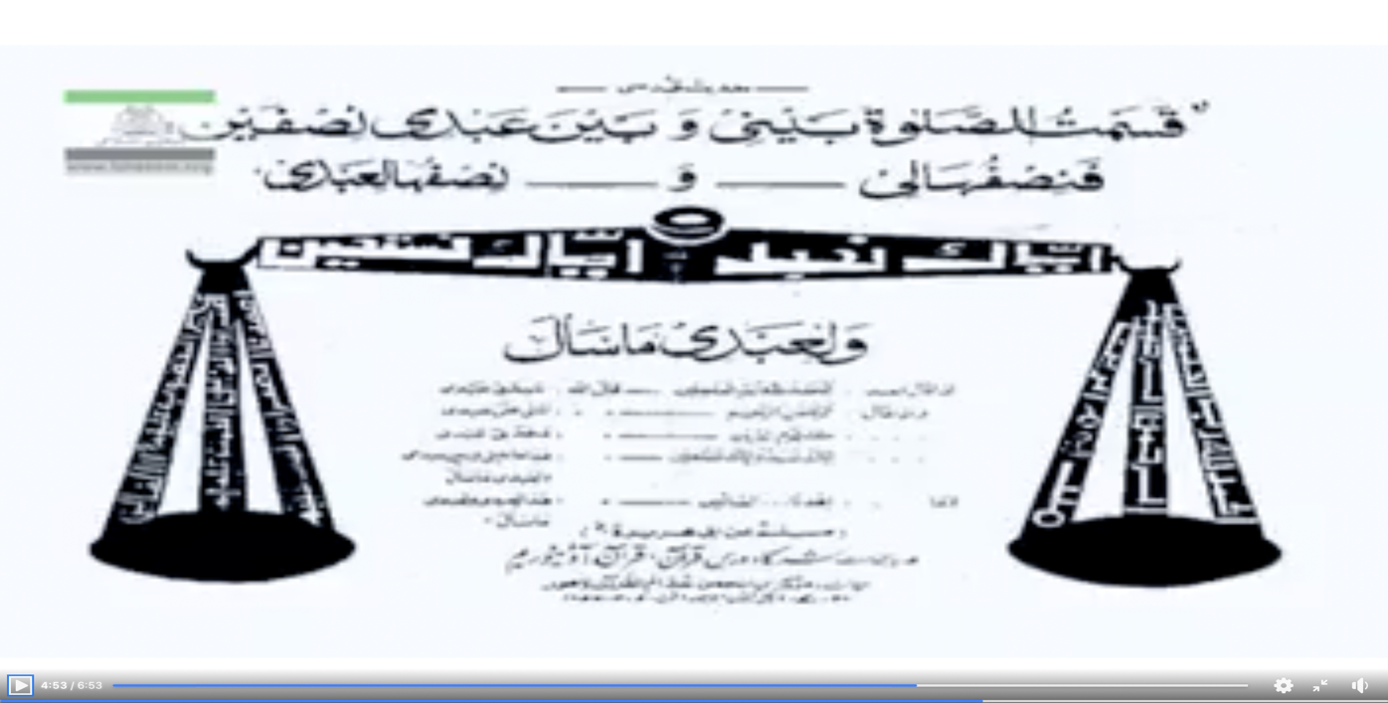

MY KEY TAKEAWAYS

THE SIGNIFICANCE AND STATUS OF SURAH AL- FATIHAH

A basic philosophy of Islam is that we are all born upon the fitra, that is, we all have instinctual or potential guidance within us as to what is right and what is wrong. All scriptures, including the Quran, help activate/awaken this dormant consciousness.
Human nature is such that even without revelations or Prophets we can come to some basic assumptions:
(Pls refer to Surah Luqman)

- There is a Creator – That this entire universe and its contents did not just come into existence by accident rather there is a Maker/Creator who is ensuring the existence along with the exact balance for everything.
- This world is but transitory. The real and final destination is the Hereafter where each will be fully compensated for their deeds and misdeeds.

Upon arriving at these two conclusions man then seeks guidance as to the straight path because as humans, we can assume a thing bad that is good and vice vera -- leading to disaster consequences. (Important to note that it is not for man to dictate or decide right from wrong or vice versa).

AH now that we are of those who have understood the majesty of our Raab and that very soon we will have to face our Raab therefore Surah Al- Fatihah is the dua for guidance so that we may gain success (Paradise).

Note: In addition to our higher nature or fitra in Islam we also have an animalistic/lower nature with cardinal desires. These instincts and desires are blind as they want nothing but immediate gratification making no difference where it is halal or haram -- we need to control these blind instincts and subjugate them to Allah SWT’s will and laws.

